Sorted Newsletter September 2024

We’re starting the new term thankful and inspired by all that God has been doing among us and the young people we serve. Firstly, we had Summer provision, which saw 25 young people per day on average come along for activities like cooking, crafts, games and more. All were fed well including one day when we had a barbecue which everyone really enjoyed. Best of all, it gave staff and volunteers chance to deepen relationships with the young people and have meaningful and unhurried conversations.

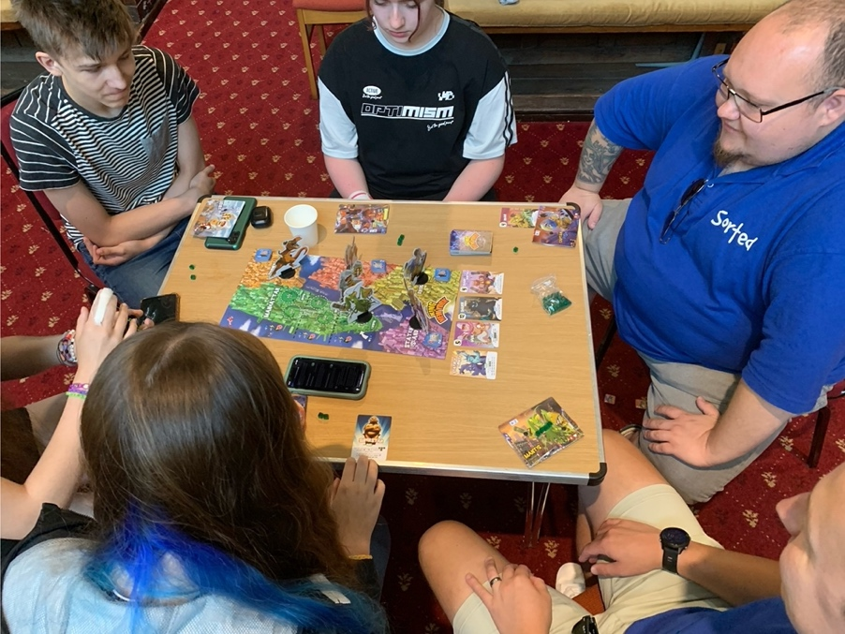

In the last week of August, Sorted took 19 young people, two vulnerable adults and 14 adults including volunteers and staff away on residential for four days. Once again we stayed at Scargill House in the Dales. It cannot be underestimated the difference it makes to a young person’s life, many of whom don’t usually get away in the Summer. Some had not been away from home before, some had not been to the Dales. We kept them busy all day with slip-and-slide, climbing, games in the park and archery. Sorted’s founder Andy, who heads up Missional Youth Church Network (MYCN) and our Pioneer Evangelist Jonny headed up the teaching each day using the film The Greatest Showman. The young people were encouraged to allow themselves time to consider discovery, belonging, where we fit in and making a fresh start and we prayed for each other.
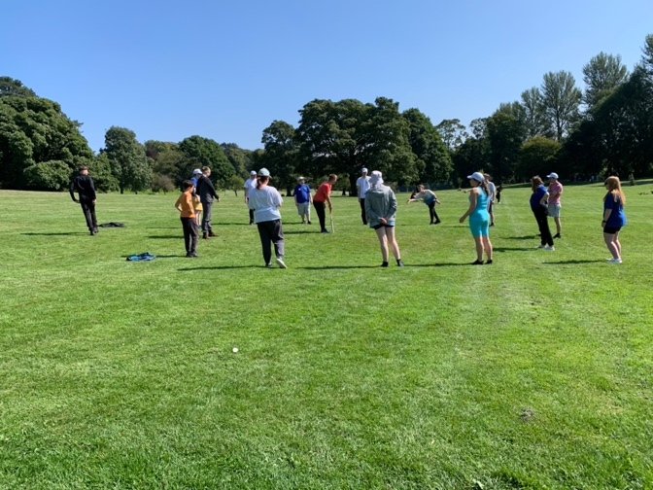
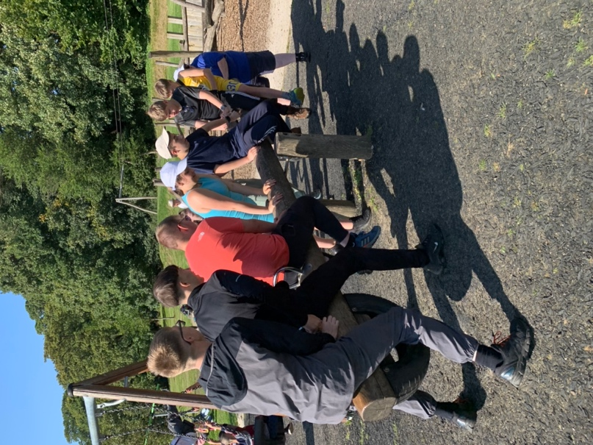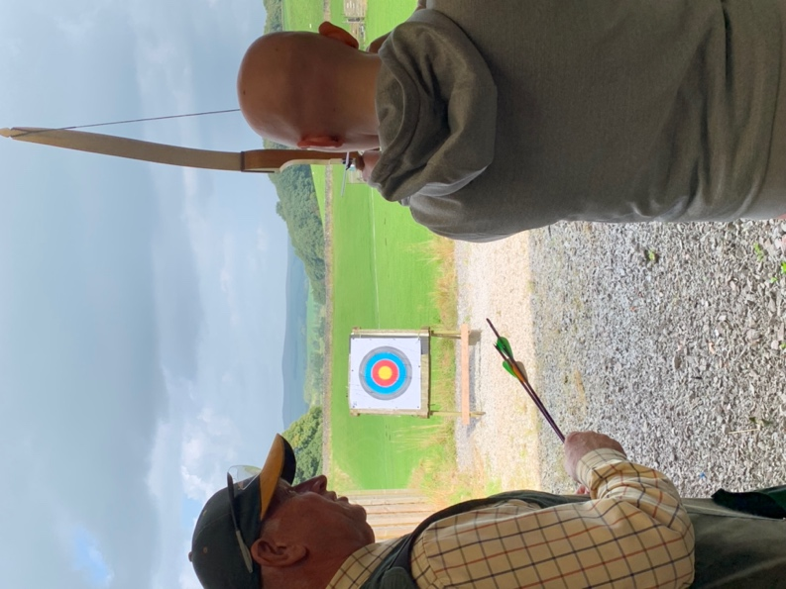

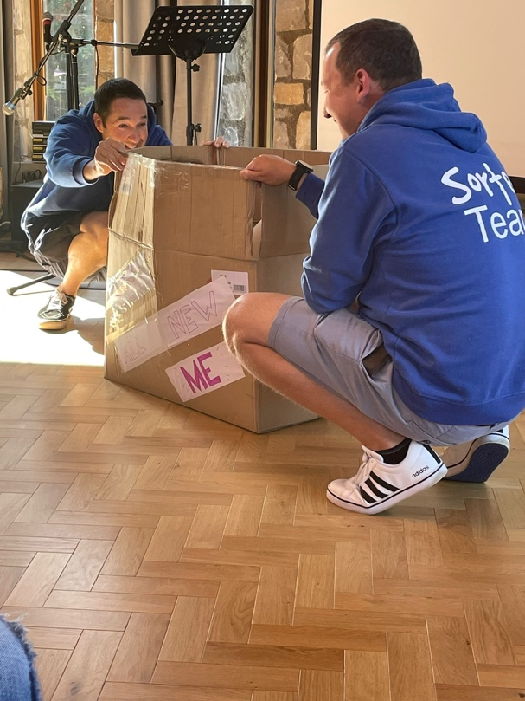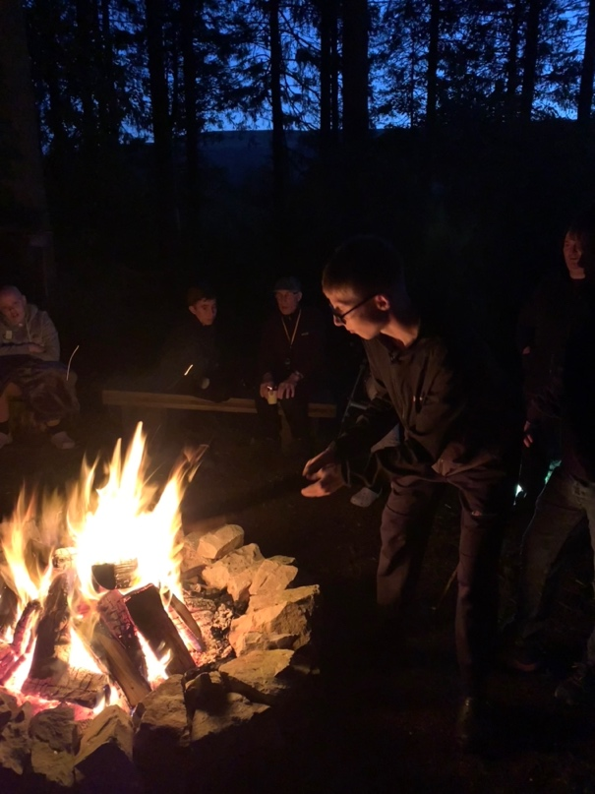

The weekend following our return home, we celebrated four baptisms: three young people who have been journeying with Sorted for the last few years and an adult from our young adults group. We look forward to confirmations to follow in November. Additionally the parent of one of the young people who was baptised has rediscovered faith through her daughter and both will be confirmed together.

So as term starts again, we’re back on with schools work. We go into the two big comprehensive schools here in North Bradford, chatting with young people in the lunch queue, keeping an eye out for those who are struggling with life and school, building relationships and discerning. In the past year, Sorted has also added an after school club into the mix. Weekly Friday night socials at our two venues became increasingly busy before the Summer and we capped the number for the first time since the lockdowns to ensure all were safe and there was enough staff/volunteers to go round. This is a very healthy sign. Sorted is run by young people, for young people and if they are voting with their feet and recommending to friends, we know we’re on the right track. Please do pray on Friday nights for safety and fun.

Young people who have got to know us and are asking the big questions are then invited to Sunday nights where we discuss issues and use the Bible as our guide. Recent topics have included the Lord’s Prayer and What Does the Bible Say About…? Our Sunday nights are also growing and we ask you to pray for others to have that faith curiosity to join us.

Wednesday nights are a Bible study group for our young adults, many of whom are also volunteers. They are encouraged to discuss the issues of college, work and relationships as they walk with God and each other. This has been going well in the past few months and has included them organising a sponsored walk to raise funds for our residential.

Jonny has now been with us a full year and has made a huge difference to us, as our full-time member of staff, sharing responsibility with myself, our ordained Young Adult Lead Robert and our Curate Marianne, who is now into her third year. We said goodbye to our youthworker Kate at the beginning of the year and we continue to hope for funds to replace her. Please do also pray for that as it would enable us to reach more young people.

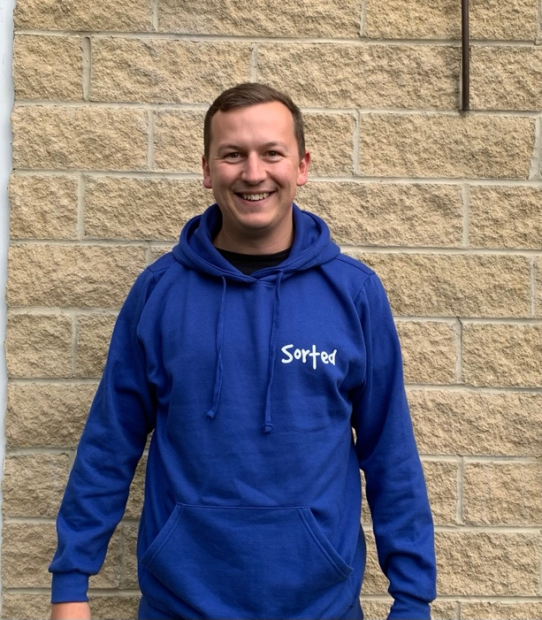
Jonny Shaw: Sorted’s Pioneer Evangelist

A recent report showed that 15-year-olds in the UK have the lowest overall life satisfaction in Europe. We see evidence of that every day and we also see the difference that Jesus makes. We are, as always, grateful to God for your continued prayers, encouragement and financial support both directly and through Church Army as we share his hope in North Bradford.

Blessings, Rev Canon Tracy Milne

