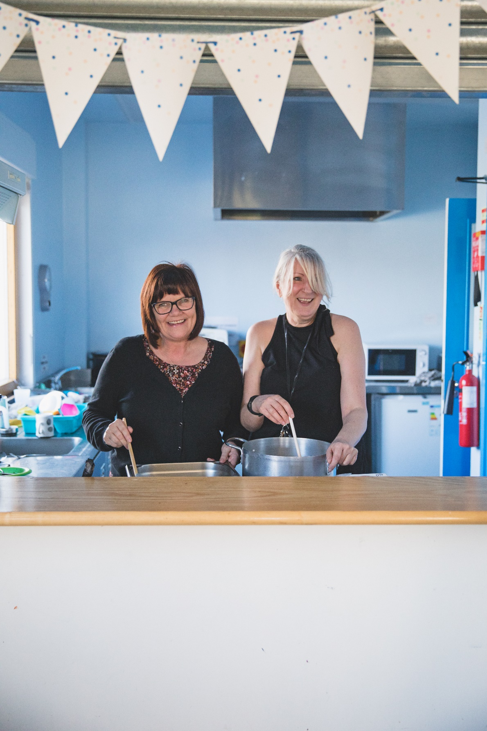

Volunteer Sanctuary

Drop-in Assistant

**At the Marylebone Project**

We’re looking for someone to provide excellent customer service at the Sanctuary. on reception. You will be someone who is welcoming, sensitive to vulnerable people who are residents and visitors to the Project. The role is within the Sanctuary team so we’re looking for someone with a good team spirit and who contributes to the maintaining of the safe environment. We will provide the necessary training and supervision.

For more information please email the volunteer

Coordinator at volunteering@churcharmy.org



**Find out more:**

Registered Charity in England 226226, Scotland SC040457, ROI 20152604. A Company Limited by guarantee, registered in England No: 37169. Registered Office: Wilson Carlile Centre, 50 Cavendish Street, Sheffield S3 7RZ